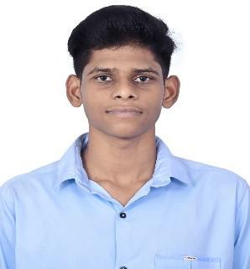
MANAV A
Ph: 9360593645
E-mail Id: manavroyals436@gmail.com
LinkedIn: https://www.linkedin.com/in/manav-a-220315249/
Github : https://github.com/manav3645

CAREER OBJECTIVE:
Looking for opportunities to incorporate my skills and training to help the company grow.
ACADEMIC QUALIFICATION:
S.N0 | COURSE | INSTITUTION | PERCENTAGE/CGPA | YEAR OF PASSING
1. | B.TECH Artificial Intelligence and Data Science | Karpagam Academy of Higher Education | Pursuing | 2025
2. | H.S.C | Sairam Matric Hr Sec School | 90.02% | 2021
3. | S.S.L.C | Sairam Matric Hr Sec School | 87.2% | 2019
PROJECT:
Completed a Mini-Project on Password Generating Tool.
Abstract: This project aims to address the vulnerability of weak passwords by developing algorithms to create strong, unique passwords for users, thereby fortifying their online accounts against unauthorized access.
AREA OF INTEREST:
- Web Development
- Data Analysis

TECHNICAL SKILLS:
- C (Intermediate)
- Python and Java (Intermediate)
- HTML and CSS
- Data Visualization Tools (Tableau and Power BI )
INTERNSHIP:
- Under grown internship conducted by Pantech E-Learning in Python Programming on 2022
- Under grown internship conducted by Pantech E-Learning in Web Development Full Stack on 2023
STRENGTH:
- Active Listening
- Decision Making
- Problem Solving
CERTIFICATE:
- Certified in "Introduction to Python" by SoloLearn in 2023
- Certified in "Introduction To Cyber Security" by Infosys Springboard in 2022
- Certified in "Introduction to Machine Learning" by Infosys Springboard in 2022
LANGUAGES KNOWN:
- English
- Tamil
PERSONAL DETAILS:
Father's Name: AMBIGAPATHY V
Date of Birth: 26/05/2004
Address: 1/128a Vadamazhai Manakkadu[Po]
Vedaranyam[Tk],Nagapattinam-614716.
DECLARATION PART
I hereby declare that all above mentioned information is in accordance with the truth of my knowledge and I bear the responsibilities for the correctness of the above-mentioned particular.
[MANAV A]

